CLIENT MEETING ABOUT MONKEY POX

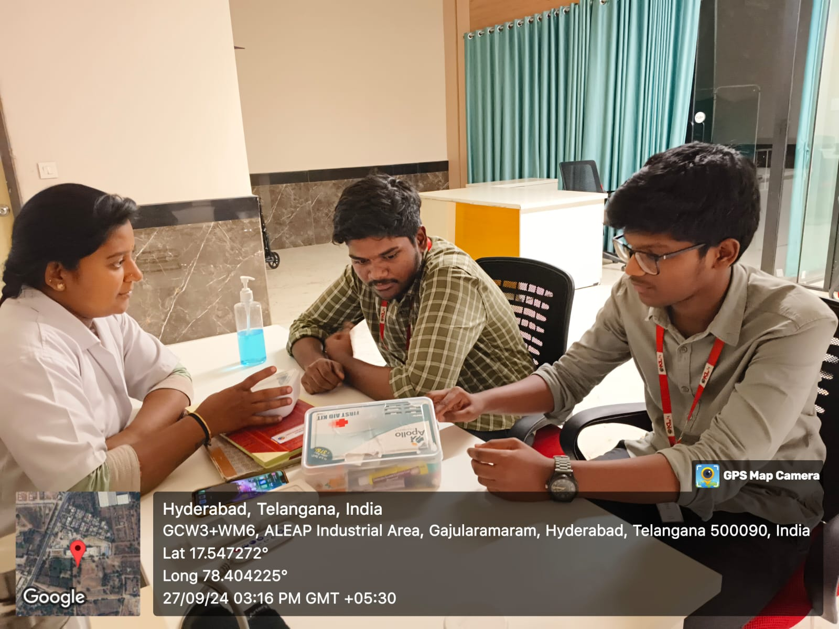

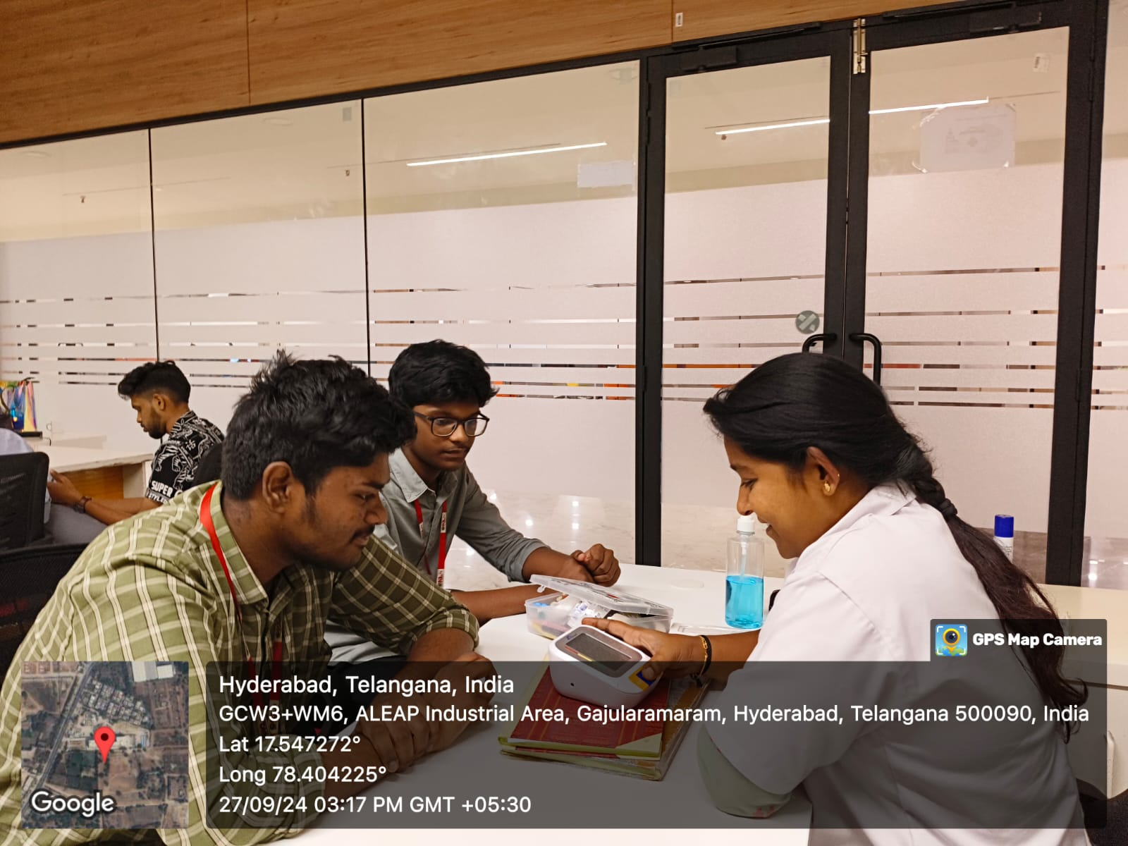

**1. What is monkeypox?**

Monkeypox is a viral zoonotic disease caused by the monkeypox virus, which is related to the smallpox virus. It leads to skin rashes, fever, and other flu-like symptoms.

**2. How does monkeypox spread?**

Monkeypox spreads through close contact with infected animals or people, bodily fluids, respiratory droplets, and contaminated objects like bedding or clothing.

**3. What are the symptoms of monkeypox?**

Symptoms include fever, headache, muscle aches, back pain, swollen lymph nodes, chills, and skin rashes that eventually form fluid-filled blisters.

**4. What does a monkeypox rash look like?**

The rash starts as red spots that evolve into raised bumps, filled with fluid or pus. These bumps eventually scab over and fall off, similar to smallpox lesions.

**5. Can monkeypox cause scarring?**

Yes, severe monkeypox infections, especially if lesions are scratched or not treated properly, can cause permanent scarring.

**6. How long does it take for monkeypox symptoms to appear after exposure?**

The incubation period is typically 5-21 days, with symptoms usually appearing around 7-14 days after exposure.

**7. Can monkeypox be confused with other skin conditions?**

Yes, monkeypox can be confused with chickenpox, measles, herpes, or even severe acne due to similar rashes. A laboratory test can confirm monkeypox.

**8. Can monkeypox affect the face?**

Yes, the rash often starts on the face before spreading to other parts of the body, including the palms, soles, and mucous membranes.

**9. Is monkeypox contagious through skin contact alone?**

Yes, direct contact with the skin lesions or bodily fluids of an infected person can transmit the virus.

**10. Can dermatologists treat monkeypox?**

While dermatologists can help manage the skin symptoms, including rashes and potential scars, treatment of the viral infection often requires antiviral medications under the care of infectious disease specialists.

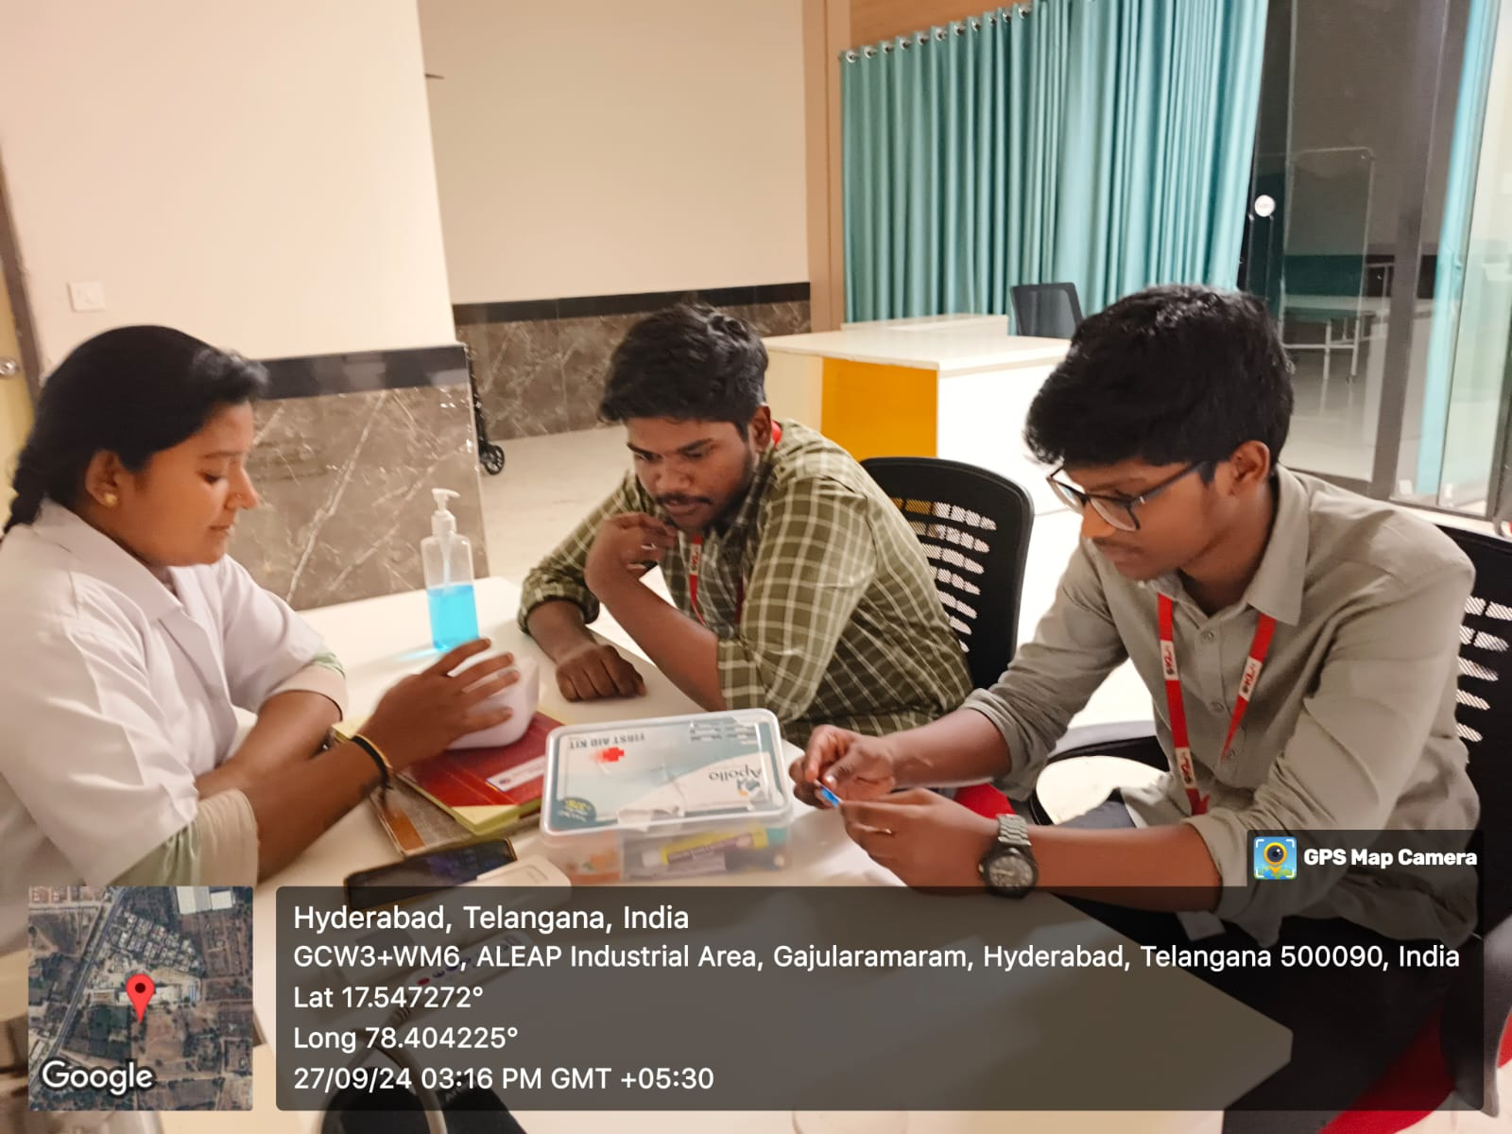

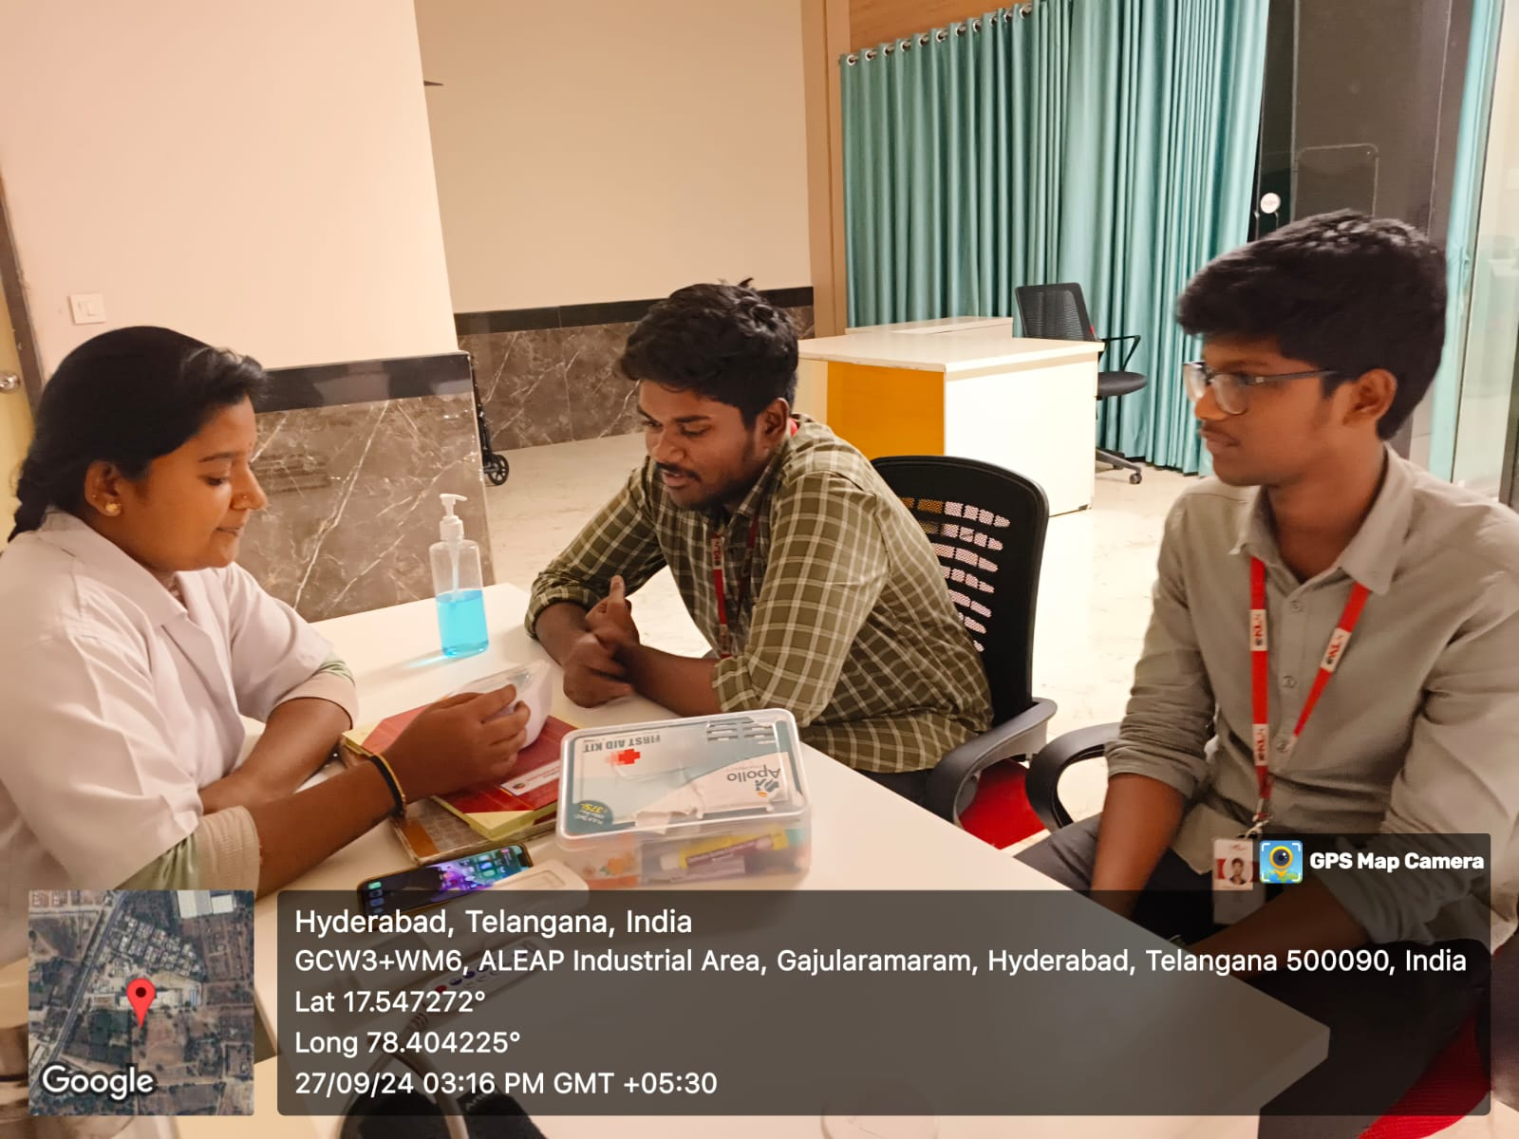

**1. Is there a vaccine for monkeypox?**

Yes, the smallpox vaccine has been shown to be about 85% effective against monkeypox. Some countries have also developed specific monkeypox vaccines.

**2. Can monkeypox lead to other skin complications?**

In severe cases, monkeypox can cause secondary bacterial skin infections, abscesses, or cellulitis, which may require antibiotic treatment.

**3. How long does the monkeypox rash last?**

The rash usually lasts 2-4 weeks, from the time the first lesions appear until they crust over and fall off.

**4. Is it safe to use over-the-counter creams on monkeypox lesions?**

Over-the-counter creams are generally not recommended unless advised by a healthcare provider, as they could interfere with proper healing.

**5. Can monkeypox be life-threatening?**

Monkeypox can be life-threatening in rare cases, especially in individuals with weakened immune systems or those with complications like bacterial infections or sepsis.

**6. Are people with eczema or skin conditions at higher risk for severe monkeypox?**

Yes, individuals with eczema or compromised skin barriers may experience more severe symptoms if they contract monkeypox.

**7. Can monkeypox be prevented through good skincare?**

Maintaining good skin hygiene may help prevent secondary bacterial infections, but the primary prevention involves avoiding contact with infected individuals or animals.

**8. Can children get monkeypox?**

Yes, children can get monkeypox, and they may be at higher risk for severe disease compared to adults.

**9. Can monkeypox affect the scalp or hair?**

Monkeypox lesions can appear on the scalp, but they typically do not affect hair growth. Hair loss is not a common symptom of monkeypox.

**10. How do dermatologists manage monkeypox scars?**

Dermatologists may use topical treatments like silicone gels, laser therapy, or chemical peels to reduce scarring, depending on the severity of the lesions.

**TEAM MEMBERS:**

V. Ajay Charan – 2320030033

K. Manjith Reddy – 2320030003

N. Gowtham – 2320090071